2/19/2026
Prepared By Manch Technology


Vendor Extension

TABLE OF CONTENTS
1. Executive Summary
1.1 Purpose
1.2 Audience
2. Project Description
2.1 Background
2.2 Objectives
3. Project Scope
3.1 In Scope
3.2 Out of Scope
4. Vendor Creation Functional Requirements
4.1 Flow Chart
4.2 Manch Terminology Reference
4.3 Initiation Methods
4.4 Field-Level Information
4.5 Process Details
4.5.1 Initiator Behaviour
4.5.2 Vendor Behaviour
4.5.3 Approver Behaviour
4.5.3.1 Approver Flow
4.5.3.2 Specific Approver Behaviour for Contributors
4.6 Reference Tables
4.7 Record List View
4.8 Communication Requirements
4.8.1 Communication Channels
4.8.2 Communication Templates
4.9 Access Management
4.10 Reporting Requirements
4.11 Integration Requirements
4.11.1 Integration Overview
4.11.2 Field-Level Mapping and Logic
4.11.3 Data Flow and Synchronization
4.11.4 Error Handling and Logging
4.11.5 API Documentations and other information
5. Assumptions
6. Appendix

1. Executive Summary

1.1 Purpose
The following steps outline the detailed flow of the process, from initiation to approval. Each step has been structured to ensure clarity, precision, and a smooth user experience.

1.2 Audience
The primary audience of this document includes business owners for procurement and finance, business analysts, project managers, solution architects, developers, and key end-users involved in vendor onboarding and maintenance. It may also be referenced by internal audit, compliance, and operations teams to validate that the implemented process aligns with policy and regulatory requirements.

2. Project Description

2.1 Background
Currently, vendor creation is handled through a mix of manual forms, email-based approvals, and direct entries into the ERP/procurement system, leading to inconsistent data quality, limited visibility, and longer cycle times. The absence of a standardized workflow and controls increase the risk of duplicate vendors, incomplete documentation, and non-compliance with internal and external regulations.

2.2 Objectives
The project aims to design and implement a controlled, workflow-driven vendor creation process that enforces mandatory data fields, documentation checks, and role-based approvals. It also seeks to improve transparency and auditability through clear status tracking, standardized communications, and integration with the organization’s master data and finance systems.

3. Project Scope

3.1 In Scope
- Capture and validation of vendor master data through a standardized vendor creation form (internal and external-facing).
- Workflow for vendor request initiation, review, and approval, and compliance as applicable.
- Storage and verification of mandatory supporting documents (e.g., tax, banking, registration, and compliance certificates).
- Creation and update of vendor records in the target ERP/procurement system, including basic integration or interface design.
- Basic reporting and dashboards for tracking vendor requests, status and turnaround times.

3.2 Out of Scope
- Changes to core ERP configuration.
- Advanced vendor performance management, risk scoring, and contract lifecycle management functionalities.
- Decommissioning or redesign of unrelated procurement processes (e.g., purchase requisition, purchase order, or invoicing flows).
- Implementation of third-party systems.

4. Vendor Creation Functional Requirements

4.1 Flow Chart
For the selections ‘PIL’ and ‘Domestic Subsidiaries’ under the ‘Choose the Group of Company’ field.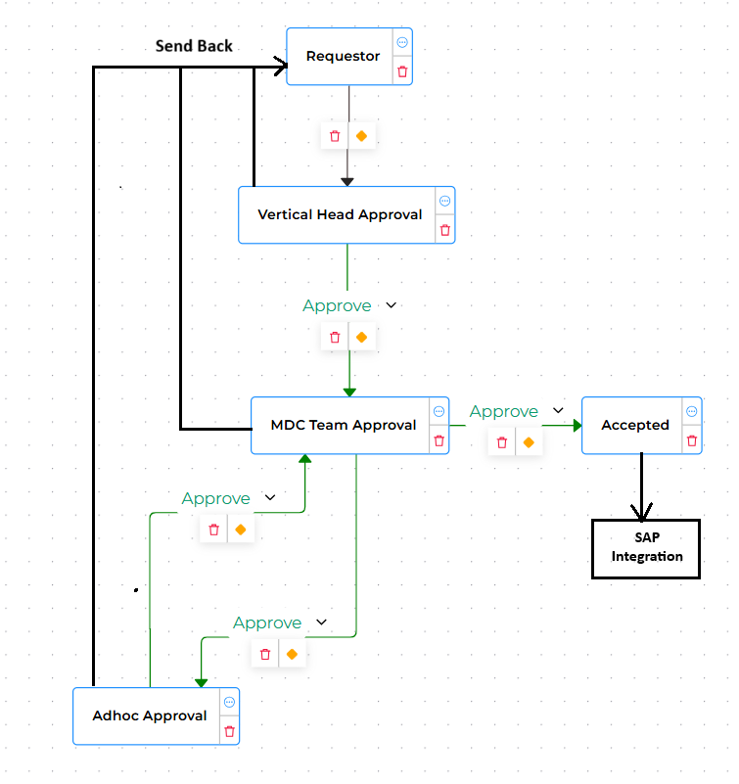

For the selection ‘International Subsidiaries’ under the ‘Choose the Group of Company’ field.
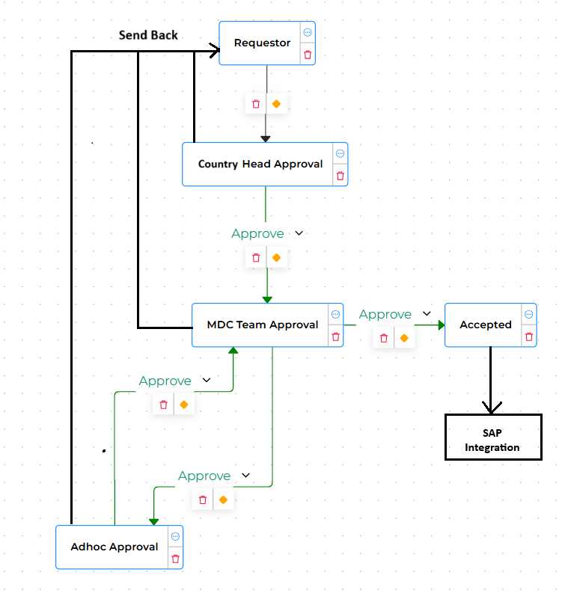

4.2 Manch Terminology Reference
BUD Terminology | Manch Terminology
Requestor / Initiator Behavior | First Party Behavior
Vendor Behavior | Second Party Behavior
Approver / Contributor Behavior | Approver or Template Participants Behavior

4.3 Initiation Methods
- The process will be initiated by the initiator by logging into the system and clicking on the create option in the dashboard.
- This process can be initiated by any user in the system. The user should be active in the Pidilite HRMS system. This data will be maintained in the Manch EDV system.
Note – Pidilite to share the format and data for maintaining access with the integration API.

4.4 Field-Level Information
Below are the details of each field used in this process, with the common logic for all stakeholders in the process.
Note – If there is any dependent dropdown, then it should be clear when the parent dropdown values are changed.
Note – If based on dropdown values, fields are visible, invisible, mandatory, or non-mandatory, then respective fields should be clear when dropdown values are changed.
Note – If the user is copying any values to another FFD and the original field is getting cleared, then copy values should also be cleared. E.g. In this process, when GST is uploaded, the GST address is copied into the address detail panel. If the GST address is getting clear, then the address details should also get clear.
Field Name+A1:D5 | Field Type | Mandatory | Logic
Basic Details | Panel
Vendor Name and Code | Dropdown | TRUE | Dropdown value should be a concatenation of first and third column from the staging Data : VC_BASIC_DETAILS  Or 1st column from Table 1.1  Copy contents of this field to `Vendor Number`.
Choose the group of Company Extension to: | Text | TRUE | The value should be auto-fetched based on the selected Vendor Name and Vendor Code from the column(Yet to be added) of the Staging Data (VC_BASIC_DETAILS) or from the first column of Reference Table 1.1. This field should be non-editable.
Vendor Number | Text | FALSE | The value should be auto-fetched based on the selected Vendor Name and Vendor Code from the first column of the Staging Data (VC_BASIC_DETAILS) or from the first column of Reference Table 1.1. This field should be non-editable.
Address Number | Text | FALSE | This value should be auto-fetched based on the selected Vendor Name and Vendor Code (First column) from the 2nd column of the Staging Data (VC_BASIC_DETAILS) or the 3rd column of Reference Table 1.1. This field should be non-editable and invisible.
Name/ First Name of the Organization | Text | FALSE | The value should be auto-fetched based on the selected Vendor Name and Vendor Code (First column) from the 3rd column of the Staging Data (VC_BASIC_DETAILS) or the 3rd column of Reference Table 1.1. This field should be non-editable.
Name/ Middle Name of the Organization | Text | FALSE | The value should be auto-fetched based on the Address Number Field (First Column) from the 8th column of the Staging Data (VC_ADDRESS_DETAILS) or from the 8th column of Reference Table 1.6. This field should be non-editable.
Name/ Last Name of the Organization | Text | FALSE | The value should be auto-fetched based on the Address Number field (First Column) from the 9th column of the Staging Data (VC_ADDRESS_DETAILS) or from the 9th column of Reference Table 1.6. This field should be non-editable.
Mobile Number / telephone 2 | Text | FALSE | The value should be auto-fetched based on the selected Vendor Name and Vendor Code (First column) from the 14th column of the Staging Data (VC_BASIC_DETAILS) or the 14th column of Reference Table 1.1. This field should be non-editable.
Email | Text | FALSE | Value should be auto-fetched based on the selected Address Number(First Column) from the 9th column of Staging data : VC_EMAIL_DETAILS or 9th column of Reference Table 1.8.(Non-editable)
Country | Text | FALSE | The value should be auto-fetched based on the Address Number field (First Column) from the 97th column of the Staging Data (VC_ADDRESS_DETAILS) or from the 97th column of Reference Table 1.6. This field should be non-editable.
Group key/Corporate Group | Text | FALSE | The value should be auto-fetched based on the selected Vendor Name and Vendor Code (First column) from the 16th column of the Staging Data (VC_BASIC_DETAILS) or the 16th column of Reference Table 1.1. This field should be non-editable.
Account Group/Vendor Type | Text | FALSE | The value should be auto-fetched based on the selected Vendor Name and Vendor Code from the column(Yet to be added) of the Staging Data (VC_BASIC_DETAILS) or from the first column of Reference Table 1.1. This field should be non-editable.
Type of Industry | Text | FALSE | Pidilite says it will be updated in Staging Data, awaiting for the update
Postal Code | Text | FALSE | The value should be auto-fetched based on the selected Vendor Name and Vendor Code (First column) from the 5th column of the Staging Data (VC_BASIC_DETAILS) or the 5th column of Reference Table 1.1. This field should be non-editable.
City | Text | FALSE | The value should be auto-fetched based on the selected Vendor Name and Vendor Code (First column) from the 4th column of the Staging Data (VC_BASIC_DETAILS) or the 4th column of Reference Table 1.1. This field should be non-editable.
Region | Text | FALSE | The value should be auto-fetched based on the selected Vendor Name and Vendor Code (First column) from the 6th column of the Staging Data (VC_BASIC_DETAILS) or the 6th column of Reference Table 1.1. This field should be non-editable.
Search term / Reference Number | Text | FALSE | Pidilite says it will be updated in Staging Data, awaiting for the update
Name of Representative | Text | FALSE | Pidilite says it will be updated in Staging Data, awaiting for the update
GST/ PAN/TAX Details | Panel
GST Vendor Classification | Text | FALSE | The value should be auto-fetched based on the selected Vendor Name and Vendor Code (from Basic Details panel) (First column) from the 11th column of the Staging Data (VC_BASIC_DETAILS) or the 11th column of Reference Table 1.1. This field should be non-editable.
GST / Tax Number 3 | Text | FALSE | The value should be auto-fetched based on the selected Vendor Name and Vendor Code (from Basic Details panel) (First column) from the 7th column of the Staging Data (VC_BASIC_DETAILS) or the 7th column of Reference Table 1.1. This field should be non-editable.
Permanent account number | Text | FALSE | The value should be auto-fetched based on the selected Vendor Name and Vendor Code (from Basic Details panel) (First column) from the 8th column of the Staging Data (VC_BASIC_DETAILS) or the 8th column of Reference Table 1.1. This field should be non-editable.
Service Tax Registration Number | Text | FALSE | The value should be auto-fetched based on the selected Vendor Name and Vendor Code (from Basic Details panel) (First column) from the 7th column of the Staging Data (VC_BASIC_DETAILS) or the 7th column of Reference Table 1.1. This field should be non-editable.
Tax Number Category | Text | FALSE | Value should be auto-fetched based on the selected Vendor Code (from Basic Details panel)(First Column) from the 87th column for Staging data : VC_COMPANY_DETAILS Or 87th column of Reference Table 1.9.(Non-editable)
Tax Number 1 | Text | FALSE | Pidilite says it will be updated in Staging Data, awaiting for the update
Tax Number 2 | Text | FALSE | Pidilite says it will be updated in Staging Data, awaiting for the update
Purchase Organization Details | Panel
Company Code and Purchase Org | ARRAY_HDR
Company Code | Text | FALSE | Value should be auto-fetched based on the selected Vendor Code (from Basic Details panel)(First Column), from the 3rd column of staging data : VC_PURCHASE_DETAILS or 3rd column of Reference Table 1.7.(Non-editable)
Order currency | Text | FALSE | Value should be auto-fetched based on the selected Vendor Code (from Basic Details panel)(First Column), from the 10th column of staging data : VC_PURCHASE_DETAILS or 10th column of Reference Table 1.7.(Non-editable)
Terms of Payment | Text | FALSE | Value should be auto-fetched based on the selected Vendor Code (from Basic Details panel)(First Column), from the 14th column of staging data : VC_PURCHASE_DETAILS or 14th column of Reference Table 1.7.(Non-editable)
Incoterms | Text | FALSE | Value should be auto-fetched based on the selected Vendor Code (from Basic Details panel)(First Column), from the 15th column of staging data : VC_PURCHASE_DETAILS or 15th column of Reference Table 1.7.(Non-editable)
Incoterms (Part 2) | Text | FALSE | Value should be auto-fetched based on the selected Vendor Code (from Basic Details panel)(First Column), from the 16th column of staging data : VC_PURCHASE_DETAILS or 16th column of Reference Table 1.7.(Non-editable)
Share with | Text | FALSE | Pidilite says it will be updated in Staging Data, awaiting for the update
Customer | Text | FALSE | Value should be auto-fetched based on the selected Vendor Code (from Basic Details panel)(First Column), from the 70th column of staging data : VC_PURCHASE_DETAILS or 70th column of Reference Table 1.7.(Non-editable)
Title | Text | FALSE | The value should be auto-fetched based on the selected Vendor Name and Vendor Code (from Basic Details panel) from the column(Yet to be added) of the Staging Data (VC_BASIC_DETAILS) or from the first column of Reference Table 1.1. This field should be non-editable.
Purchase Organization | Text | FALSE | Value should be auto-fetched based on the selected Vendor Code (from Basic Details panel)(First Column), from the 2nd column of staging data : VC_PURCHASE_DETAILS or 2nd column of Reference Table 1.7.(Non-editable)
Company Code and Purchase Org | ARRAY_END
Ext CC and PO | ARRAY_HDR
Extended Company Code | Dropdown | TRUE | The dropdown values should be populated from the third column of EDV: COMPANY_CODE_PURCHASE_NEW or from the third column of Reference Table 1.2.  The Company Code values must populate dynamically based on the selected group under “Choose the Group of Company (from Basic Details panel).”  The selected Group of Company corresponds to the first column of COMPANY_CODE_PURCHASE_NEW.  Available group values:  PIL  Domestic Subsidiaries  International Subsidiaries
Extended Purchase Organization | Dropdown | TRUE | The dropdown values should be populated from the 7th column of EDV: COMPANY_CODE_PURCHASE_NEW or from the 7th column of Reference Table 1.2.  The Company Code values must populate dynamically based on:  The selected Group under “Choose the Group of Company (from Basic Details panel)”  (First column of COMPANY_CODE_PURCHASE_NEW)  The selected Company Code  (Third column of COMPANY_CODE_PURCHASE_NEW)  Available group values:  PIL  Domestic Subsidiaries  International Subsidiaries
Order currency | Dropdown | TRUE | Dropdown values will be derived from first column of the EDV : CURRENCY_COUNTRY
Terms of Payment | Dropdown | TRUE | Dropdown values will be derived from first column of the EDV reference table : TERMS_OF_PAYMENT
Incoterms | Dropdown | TRUE | Dropdown values will be derived from the first column of the EDV : INCOTERMS
Incoterms (Part 2) | Text | TRUE | Free text field
Ext CC and PO | ARRAY_END

4.5 Process Details
Below are the details of each step of the process.

4.5.1 Initiator Behaviour
- Login: The Pidilite team logs in to the Manch application using the provided credentials. The following basic details are shown to the user for each transaction created.
  - Transaction ID
  - Company Name – Title (Copy the company name FFD Data into Title)
  - Process Name
  - Vendor Code – Attribute 1 (Copt the vendor code FFD Data into Attribute 1)
  - Create By – Show the created by email id
  - Created Date
  - Status – Display the external status with next approver and rejection details (when applicable)
- Initiation: The user will click on the create option and select the vendor creation process.
- Form will open with the below details of initiator. Initiator will be able to view only Basic details panel and fields as mentioned below. All the fields will be having common logic with them.
Field Name+A1:D5 | Field Type | Mandatory | Logic
Basic Details | Panel
Vendor Name and Code | Dropdown | TRUE
Choose the group of Company Extension to: | Dropdown | TRUE
Vendor Number | Text | FALSE
Name/ First Name of the Organization | Text | FALSE
Name/ Middle Name of the Organization | Text | FALSE
Name/ Last Name of the Organization | Text | FALSE
Name 4/Alternate Name | Text | FALSE
Mobile Number / telephone 2 | Text | FALSE
Email | Text | FALSE
Country | Text | FALSE
Group key/Corporate Group | Text | FALSE
Account Group/Vendor Type | Text | FALSE
Type of Industry | Text | FALSE
Street | Text | FALSE
Street 1 | Text | FALSE
Street 2 | Text | FALSE
Street 3 | Text | FALSE
District | Text | FALSE
Postal Code | Text | FALSE
City | Text | FALSE
Region | Text | FALSE
Search term / Reference Number | Text | FALSE
Name of Representative | Text | FALSE
GST/ PAN/TAX Details | Panel | FALSE
GST Vendor Classification | Text | FALSE
GST / Tax Number 3 | Text | FALSE
Permanent account number | Text | FALSE
Service Tax Registration Number | Text | FALSE
Tax Number Category | Text | FALSE
Tax Number 1 | Text | FALSE
Tax Number 2 | Text | FALSE
Language Key | Text | FALSE
ID Type | Text | FALSE
CIN /TDS/MSME Details | Panel
FDA Registration Number CIN | Text | FALSE
MSME Number (Tax Number 4) | Text | FALSE
MSME status | Text | FALSE
Bank Details | Panel | FALSE
Bank Country | Text | FALSE
Bank Key | Text | FALSE
Bank Account Number | Text | FALSE
Account holder | Text | FALSE
Withholding Tax and Payment Details | Panel | FALSE
Withholding Tax Type | Text | FALSE
Subject to w/tax | Text | FALSE
Recipient Type | Text | FALSE
Withholding Tax Code | Text | FALSE
Posting block for company code | Text | FALSE
Reconciliation Account | Text | FALSE
Payment Methods | Text | FALSE
Currency | Text | FALSE
Purchase Organization Details | Panel | FALSE
Company Code and Purchase Org | ARRAY_HDR | FALSE
Company Code | Text | FALSE
Order currency | Text | FALSE
Terms of Payment | Text | FALSE
Incoterms | Text | FALSE
Incoterms (Part 2) | Text | FALSE
Share with | Text | FALSE
Customer | Text | FALSE
Title | Text | FALSE
Purchase Organization | Text | FALSE
Company Code and Purchase Org | ARRAY_END
Company Code and Purchase Org | ARRAY_HDR
Extended Company Code | Dropdown | TRUE
Extended Purchase Organization | Dropdown | TRUE
Order currency | Dropdown | TRUE
Terms of Payment | Dropdown | TRUE
Incoterms | Dropdown | TRUE
Incoterms (Part 2) | Text | TRUE
Company Code and Purchase Org | ARRAY_END

- Once the Initiator enters the details and clicks on submit. The system will perform the validation and send the details to the vendor for them to take action.

4.5.3 Approver Behavior

4.5.3.1 Approver flow for Vendor Extension PIL/Domestic Subsidiaries
- Approver access: Approvers have two methods to access the transaction, review and act on requests as mentioned below -
  - Email Notification:
    - The Manch system sends an email notification to the approver with a link to review the request. Approver can click on the link and view all the details of the requests.
    - Email Content:

Subject: Vendor Management Request – Approval Notification

Dear User,

The Vendor Management request has been successfully approved and is currently undergoing the next steps in the workflow. Please see the details below:

The Vendor Extension request has been submitted for your approval. Please see the details below:

Request Summary
Type: Vendor Management
Vendor Name: XYZ
Created By: XYZ
Creation Date: 11/11/2025
Reference Number: 326748
Application Link: Access the Application (Approver Link)

The above data can also be viewed using Approver Link

Regards,
Team Pidilite.
  - Manch System Login:
    - The approver can log in to the Manch platform through SSO login. Approver will view the respective dashboard with pending approver requests.

4.5.3.2 Approver flow for Vendor Extension International Subsidiaries.
- Approver access: Approvers have two methods to access the transaction, review and act on requests as mentioned below -
  - Email Notification:
    - The Manch system sends an email notification to the approver with a link to review the request. Approver can click on the link and view all the details of the requests.
    - Email Content:

Subject: Vendor Management Request – Approval Notification

Dear User,

The Vendor Management request has been successfully approved and is currently undergoing the next steps in the workflow. Please see the details below:

The Vendor Extension request has been submitted for your approval. Please see the details below:

Request Summary
Type: Vendor Management
Vendor Name: XYZ
Created By: XYZ
Creation Date: 11/11/2025
Reference Number: 326748
Application Link: Access the Application (Approver Link)

The above data can also be viewed using Approver Link

Regards,
Team Pidilite.
  - Manch System Login:
    - The approver can log in to the Manch platform through SSO login. Approver will view the respective dashboard with pending approver requests.

Approver 1 – Vertical Head Approver Behavior

Approver will be fetched from the EDV : VENDORFLOWAPPROVERLOGICUPDATE based on Company Code/ ID selection.
- Approver 1 will view all the information entered by requestor in non-editable mode.
- Approver should view old data points and validated information. Based on all the information available to approver, they can approve or reject or send back.
  - If approver rejects, transaction will be in rejection status and no further actions are allowed in the request.
  - If approver send back, transaction will be assigned back to requestor. Requestor will get the email notification can login into the Manch platform to view the comment and update the required data.
    - Email Content:
Subject: Vendor Management Request – Send Back/Rejection Notification

Dear Users,

The Vendor Management request has been sent back with below details:

Request Summary
Type: Vendor Management
Vendor Name: XYZ
Created By: XYZ
Creation Date: 11/11/2025
Reference Number: 326748
Remark:*

Regards,
Team Pidilite.

  - Once requestor re-submits, transaction will follow all the steps of the workflow.

Approver 2 - MDC Head Approver Behavior

Approver will be fetched from Dynamic approver group set-up
- Approver 2 will view all the information entered by previous stakeholders (requestor and approver 1). Approver 2 will not be able to edit any data points.
- Approver should view old data points, and validated the information. Based on all the information available to approver , they can approve or reject or send back or send the request to Adhoc Approver.
○ If approver rejects, transaction will be in rejection status and no further actions are allowed in the request.
○ If approver send back, transaction will be assigned back to requestor. Requestor will get the email notification can login into the Manch platform to view the comment and update the required data.
■ Rejection Email Content:
Subject: Vendor Management Request – Send Back/Rejection Notification

Dear Users,
The Vendor Management request has been sent back with below details:
Request Summary
Type: Vendor Management
Vendor Name: XYZ
Created By: XYZ
Creation Date: 11/11/2025
Reference Number: 326748
Application Link: Access the Application
Status: The request is sent back by MDC:
Remark:*

Regards,
Team Pidilite.
- If approver decides to send the request to Adhoc approver, Adhoc approver selection option to be given and it will be routed to the selected Adhoc Approver for further steps.

Approver 3 - Adhoc Approver Behavior

- Approver 3 will view all the information entered by previous stakeholders (requestor, approver 1 and approver 2). Approver 3 will not be able to edit any data points.
- Approver should view old data points and validated information. Based on all the information available to approver, they can approve or reject or send back or send the request to Adhoc Approver.
○ If approver rejects, transaction will be in rejection status and no further actions are allowed in the request.
○ If approver send back, transaction will be assigned back to requestor. Requestor will get the email notification can login into the Manch platform to view the comment and update the required data.
■ Rejection Email Content:
Subject: Vendor Management Request – Send Back/Rejection Notification

Dear Users,
The Vendor Management request has been sent back with below details:
Request Summary
Type: Vendor Management
Vendor Name: XYZ
Created By: XYZ
Creation Date: 11/11/2025
Reference Number: 326748
Application Link: Access the Application
Status: The request is sent back by MDC:
Remark:*

Regards,
Team Pidilite.
- If approver approves the request, it will route back to MDC Head Approver for further steps.
- MDC Approver will then approve the request to go Accepted status and SAP integration will be triggered.

Approver 1 – Country Head Approver Behavior

Approver will be fetched from a Dynamic approver group for Country Head.
- Approver 1 will view all the information entered by requestor in non-editable mode.
- Approver should view old data points and validated information. Based on all the information available to approver, they can approve or reject or send back.
  - If approver rejects, transaction will be in rejection status and no further actions are allowed in the request.
  - If approver send back, transaction will be assigned back to requestor. Requestor will get the email notification can login into the Manch platform to view the comment and update the required data.
    - Email Content:
Subject: Vendor Management Request – Send Back/Rejection Notification

Dear Users,

The Vendor Management request has been sent back with below details:

Request Summary
Type: Vendor Management
Vendor Name: XYZ
Created By: XYZ
Creation Date: 11/11/2025
Reference Number: 326748
Remark:*

Regards,
Team Pidilite.

  - Once requestor re-submits, transaction will follow all the steps of the workflow.

Approver 2 - MDC Head Approver Behavior

Approver will be fetched from a Dynamic approver group for Country Head.
- Approver 2 will view all the information entered by previous stakeholders (requestor and approver 1). Approver 2 will not be able to edit any data points.
- Approver should view old data points, and validated the information. Based on all the information available to approver , they can approve or reject or send back or send the request to Adhoc Approver.
○ If approver rejects, transaction will be in rejection status and no further actions are allowed in the request.
○ If approver send back, transaction will be assigned back to requestor. Requestor will get the email notification can login into the Manch platform to view the comment and update the required data.
■ Rejection Email Content:
Subject: Vendor Management Request – Send Back/Rejection Notification

Dear Users,
The Vendor Management request has been sent back with below details:
Request Summary
Type: Vendor Management
Vendor Name: XYZ
Created By: XYZ
Creation Date: 11/11/2025
Reference Number: 326748
Application Link: Access the Application
Status: The request is sent back by MDC:
Remark:*

Regards,
Team Pidilite.
- If approver decides to send the request to Adhoc approver, Adhoc approver selection option to be given and it will be routed to the selected Adhoc Approver for further steps.

Approver 3 - Adhoc Approver Behavior

- Approver 3 will view all the information entered by previous stakeholders (requestor, approver 1 and approver 2). Approver 3 will not be able to edit any data points.
- Approver should view old data points and validated information. Based on all the information available to approver, they can approve or reject or send back or send the request to Adhoc Approver.
○ If approver rejects, transaction will be in rejection status and no further actions are allowed in the request.
○ If approver send back, transaction will be assigned back to requestor. Requestor will get the email notification can login into the Manch platform to view the comment and update the required data.
■ Rejection Email Content:
Subject: Vendor Management Request – Send Back/Rejection Notification

Dear Users,
The Vendor Management request has been sent back with below details:
Request Summary
Type: Vendor Management
Vendor Name: XYZ
Created By: XYZ
Creation Date: 11/11/2025
Reference Number: 326748
Application Link: Access the Application
Status: The request is sent back by MDC:
Remark:*

Regards,
Team Pidilite.
- If approver approves the request, it will route back to MDC Head Approver for further steps.
- MDC Approver will then approve the request to go Accepted status and SAP integration will be triggered.

4.6 Reference Tables

Table 1.1
Table 1.2

Table 1.3
Table 1.4
Table 1.5

Table 1.6
Table 1.7
Table 1.8
Table 1.9
Table 1.10

4.7 Record List View
List key fields to be displayed on user/admin dashboards for quick reference.
It will have below mentioned columns
  - Transaction ID
  - Company Name – Title (Copy the company name FFD Data into Title)
  - Process Name
  - Vendor Code – Attribute 1 (Copt the vendor code FFD Data into Attribute 1)
  - Create By – Show the created by email id
  - Created Date
  - Status – Display the external status with next approver and rejection details (when applicable)

4.8 Communication Requirements
Effective communication is pivotal to the success of the vendor creation process. This section delineates the communication strategies, channels, templates, and protocols to ensure timely and accurate information dissemination among stakeholders.

4.8.1 Communication Channels
Identify and utilize appropriate channels for different types of communication.:
- Email: For formal notifications, approvals, and escalations.

4.8.2 Communication Templates
Standardize messages to ensure consistency and professionalism:
- Email Templates For Vendor
Subject: On behalf of Pidilite - Request to process the document | Title: Vendor Creation
Body : Dear [Name of vendor],
Welcome to the Pidilite Vendor Onboarding Process. Click the {link} to access your account and continue with the application process.
Kindly ensure the following documents are submitted in PDF and JPEG format, with each file not exceeding 4 MB in size:
a) GST Certificate – If registered/Applicable
b) PAN Card – Mandatory
c) Aadhaar Card – If applicable
d) Bank Details / Cancelled Cheque – Mandatory (Alternatively, a Bank Authorization Letter is acceptable)
e) MSME Certificate – If applicable
f) CIN (Corporate Identification Number) – Mandatory if registered as a company
We appreciate your cooperation in providing these documents.

Note: This is a system-generated email. Please do not revert.
Thanks,
Team Pidilite

- Email Templates For Approver
Subject: On behalf of Pidilite - Request to Approve the document | Title: Vendor Creation
Body: Please review the document in the following link and provide the approval
- Link
Please contact support@manchtech.com for further support.
Regards,
Team Pidilite.

4.9 Access Management

All users will have access to create a vendor in the system. Pidilite to share the user list.

4.10 Reporting Requirements
To be discussed with The Pidilite
Specify reporting needs, including:
- Types of reports (e.g., dashboards, TAT reports etc.)
- Data derivation logic
- Access controls

4.11 Integration Requirements
To be discussed with The Pidilite

4.11.1 Integration Overview
- Integration Objectives: Define the purpose of each integration, such as data synchronization, real-time updates, or batch processing.
- External Systems Involved: List all third-party systems, applications, or databases that will interface with the process.

4.11.2 Field-Level Mapping and Logic
Provide a detailed mapping of fields between the internal system and each external system.

Internal Field Name | External System | External Field Name | Data Type | Transformation Logic | Mandatory | Default Value | Validation Rules
Field A | System X | Ext_Field_A | String | Uppercase Conversion | Yes | N/A | Regex Pattern
Field B | System Y | Ext_Field_B | Date | Format to YYYY-MM-DD | No | Current Date | Date Range Check

4.11.3 Data Flow and Synchronization
- Data Directionality:
  - Outbound: Data sent from the internal system to external systems.
  - Inbound: Data received from external systems into the internal system.
- Synchronization Frequency:
  - Real-Time: Immediate data exchange upon event triggers.
  - Scheduled: Data exchange occurs at defined intervals (e.g., hourly, daily).
- Conflict Resolution: Define rules for handling data discrepancies, such as prioritizing the most recent update or flagging for manual review.

4.11.4 Error Handling and Logging
- Error Detection: Mechanisms to identify integration failures, such as missing fields or data type mismatches.

4.11.5 API Documentations and other information
- Add API documentation available for each system.
- Add other information related to integration

5. Assumptions
Document any assumptions made during the requirements gathering process that could impact the project's success.

6. Appendix
Include supplementary materials such as process diagrams, data models, or detailed analyses that support the BUD.

7. DEPENDENCIES AND QUERIES
- We await the customized dashboard view that needs to be displayed for the initiator/requestor.
- Sample data for Approver derivation logic and matrix
- SAP API development and enablement for Manch Interface
- Do we have different approvers for each Company Code, or is there a common approver for all Company Codes under the selected ‘Choose the Group of Company’?
- Are we extending the Company Code and Purchase Organization from one ‘Choose the Group of Company’ category to another (e.g., from PIL to Domestic or International, and vice versa)? If yes, based on which field are we defining the approver flow?

Mandatory Guidelines for Document Writing

- Formatting Best Practices:
- Consistent Numbering: Implement a hierarchical numbering system (e.g., 1, 1.1, 1.1.1) to clearly differentiate between sections and subsections.
- Styles and Formatting: Adopt consistent heading styles and formatting to enhance readability and project a professional image.
- Table of Contents: Automatically generate a table of contents based on heading styles to ensure effortless navigation.
- Version Control: Always include version numbers and revision dates to effectively track changes over time.
- Review and Approval: Enforce sections for stakeholder review and approval to guarantee alignment and secure necessary sign-off.

